

Winter Semester 2017-18

**Live Migration on KVM**

# PROJECT REPORT

**Submitted for CAL in B.Tech Virtualization(CSE4011)**

**By**

**Tushar Pahuja 15BCE1252**

**Osho Agyeya 15BCE1326**

**Shivam Attree 15BCE1044**

**Faculty**: **Prof Kumar R.**

**(SCHOOL OF COMPUTING SCIENCE AND ENGINEERING)**

## CERTIFICATE

This is to certify that the Project work entitled “***LIVE MIGRATION ON KVM***” that is being submitted by “***TUSHAR PAHUJA, OSHO AGYEYA, SHIVAM ATTREE***” for CAL in B.Tech Virtualisation (CSE4011) is a record of bonafide work done under my supervision.

Place: Chennai

Date: 05/04/2018

**Signature of Students**:

TUSHAR PAHUJA

OSHO AGYEYA

SHIVAM ATTREE

**Signature of Faculty:**

Prof Kumar R

## ACKNOWLEDGEMENTS

We thank VIT University (**SCHOOL OF COMPUTING SCIENCE AND ENGINEERING**) for giving us the opportunity to conduct this project and experiment. We also thank our guide for project Dr. R Kumar for his constant, good and knowledgeable guidance for the project. Through this project, we learned many of new things about Live Migration and Virtualisation which will be definitely useful for us.

OSHO AGYEYA TUSHAR PAHUJA ` SHIVAM ATTREE

Reg. No. 15BCE1326 Reg. No. 15BCE1252 Reg. No. 15BCE1044

## ABSTRACT

Live migration enables the movement of virtual machines (VMs) from one physical host to another without downtime. It’s often used when administrators need to perform hardware maintenance on a physical host. You can just live-migrate all VMs off the host, then live-migrate them back once maintenance is completed. Migration describes the process of moving a guest virtual machine from one host physical machine to another. This is possible because guest virtual machines are running in a virtualized environment instead of directly on the hardware. Performing a KVM live migration requires the the same kind of CPU on the hosts, the same kernel version and shared storage among the migrating VMs. Shared storage ensures that the host computers can access the storage back end during a KVM live migration.

This project is aimed at performing live migration of a linuxmint virtual machine between two Ubuntu physical hosts using Virtual Machine Manager. Along with this, all the necessary system setup and installation has been described in detail.

Introduction

Live migration refers to the process of moving a running virtual machine or application between different physical machines without disconnecting the client or application. Memory, storage, and network connectivity of the virtual machine are transferred from the original guest machine to the destination.



**REQUIREMENTS:**

1. OS – Ubuntu 16.04 (any OS can be used but all the host involved in Live Migration should have the same OS).

2. Hypervisor – KVM (any linux based hypervisor can be used eg. Xen for managing the VMs)

3. Shared Storage – NFS (most important requirement for the Live Migration)

4. Virtual Machines – Any number of VMs can be created and can be managed by using KVM (Kernel Virtual Machine)

**CONCEPTS:**

*1. VIRTUAL MACHINE*

A Virtual Machine is an Operating System or application environment that is installed on software which imitates dedicated hardware. The end user has the same experience on a Virtual Machine as they would have on dedicated hardware.

*2. LIVE MIGRATION*

Live Migration refers to the process of moving a running Virtual Machine or application between different physical machines without disconnecting the client or application.

*3. KVM (Kernel Virtual Machine)*

Kernel-based Virtual Machine (KVM) is a virtualization infrastructure for the linux kernel that turns it into a hypervisor.

*4. NFS*

NFS, or Network File System, is a distributed file system protocol that allows you to mount remote directories on your server. NFS provides a relatively quick and easy way to access systems over a network and works well in situations where the shared resources will be accessed regularly.

Migration works by sending the state of the guest virtual machine's memory and any virtualized devices to a destination host physical machine. It is recommended to use shared, networked storage to store the guest virtual machine's images to be migrated. It is also recommended to use libvirt-managed storage pools for shared storage when migrating virtual machines.

### MOTIVATION

Migration is useful for:

* Load balancing - guest virtual machines can be moved to host physical machines with lower usage when their host physical machine becomes overloaded, or another host physical machine is under-utilized.
* Hardware independence - when we need to upgrade, add, or remove hardware devices on the host physical machine, we can safely relocate guest virtual machines to other host physical machines. This means that guest virtual machines do not experience any downtime for hardware improvements.
* Energy saving - guest virtual machines can be redistributed to other host physical machines and can thus be powered off to save energy and cut costs in low usage periods.
* Geographic migration - guest virtual machines can be moved to another location for lower latency or in serious circumstances.

Migrations can be performed live or not.

In a **live migration**, the guest virtual machine continues to run on the source host physical machine while its memory pages are transferred, in order, to the destination host physical machine. During migration, KVM monitors the source for any changes in pages it has already transferred and begins to transfer these changes when all of the initial pages have been transferred. KVM also estimates transfer speed during migration, so when the remaining amount of data to transfer will take a certain configurable period of time, KVM suspends the original guest virtual machine, transfers the remaining data, and resumes the same guest virtual machine on the destination host physical machine.

A migration that is **not performed live**, suspends the guest virtual machine, then moves an image of the guest virtual machine's memory to the destination host physical machine. The guest virtual machine is then resumed on the destination host physical machine and the memory the guest virtual machine used on the source host physical machine is freed. The time it takes to complete such a migration depends on network bandwidth and latency. If the network is experiencing heavy use or low bandwidth, the migration will take much longer.

If the original guest virtual machine modifies pages faster than KVM can transfer them to the destination host physical machine, offline migration must be used, as live migration would never complete.

### IMPLEMENTATION DETAILS

STEPS INVOLVED:

1. INSTALLATION OF UBUNTU ON PHYSICAL HOSTS

The first step is to ensure that Ubuntu 16.04 is properly installed on both physical machines and is up and running.

The image can be obtained from <http://releases.ubuntu.com/16.04.4/>

The steps below are supposed to be executed on both the hosts.

1. INSTALLING OF KVM & VERIFICATION

The following screenshots showcase the installation and verification of KVM:

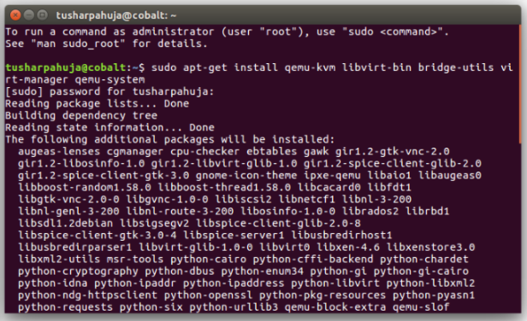

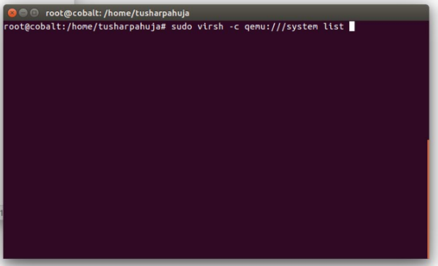

1. NFS MOUTING
2. This needs to be done carefully. Both machines act as separate hosts.
3. NFS is a common directory on both the host 1 and host 2.
4. Host 1 ip address: 192.168.43.121 (Tushar’s PC)
5. Host 2 ip address: 192.168.43.121 (Osho’s PC)
6. The following screenshots showcase the installation:  
     
   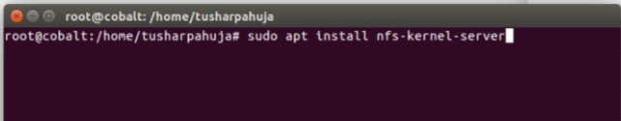
7. Make a directory for NFS:

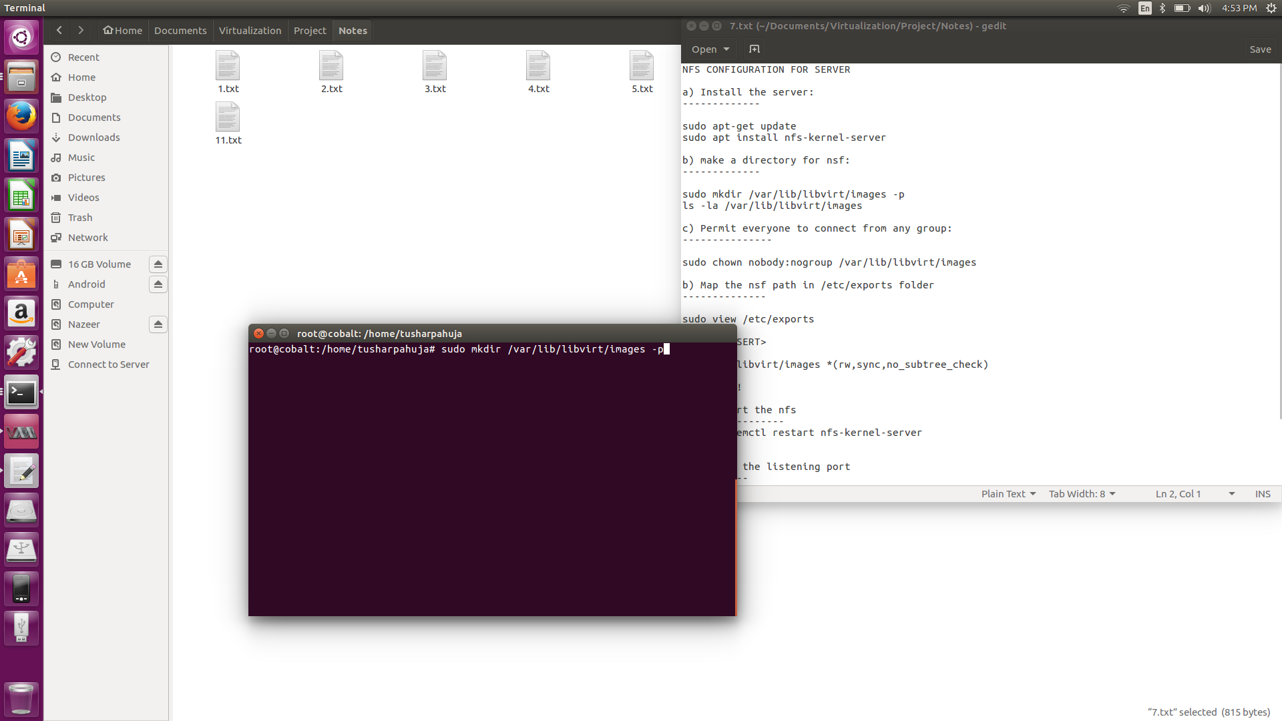

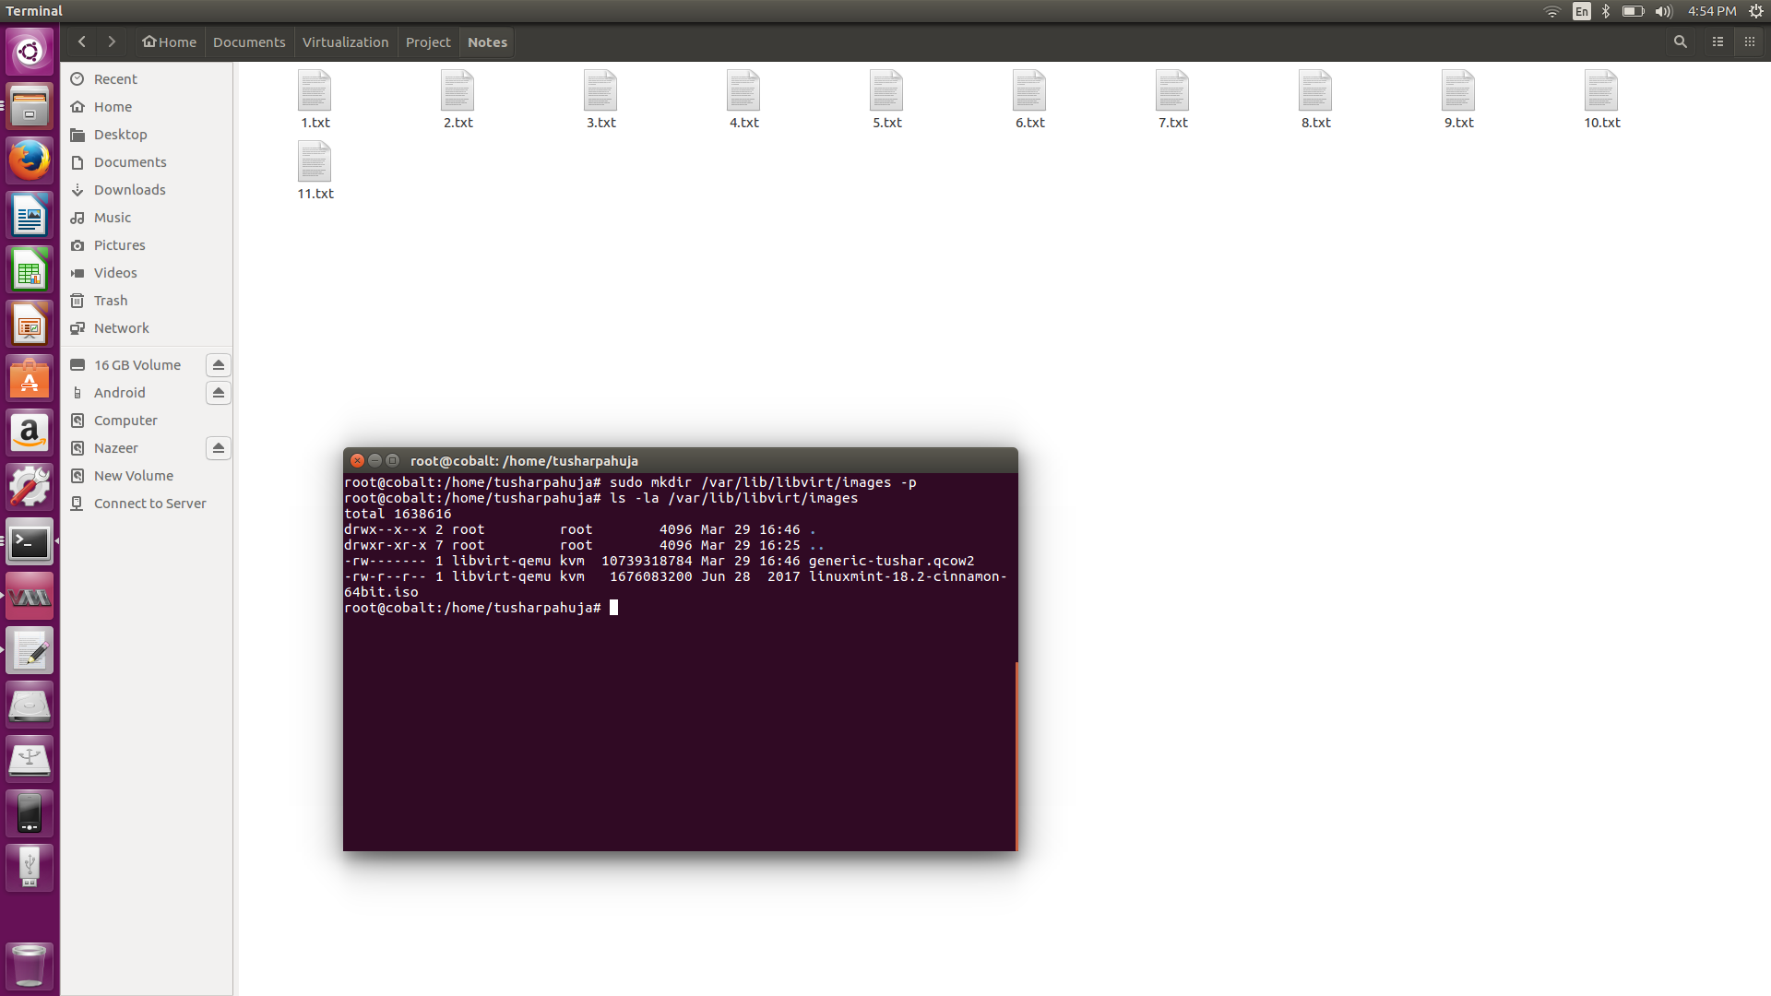

1. Permit everyone to connect from any group:

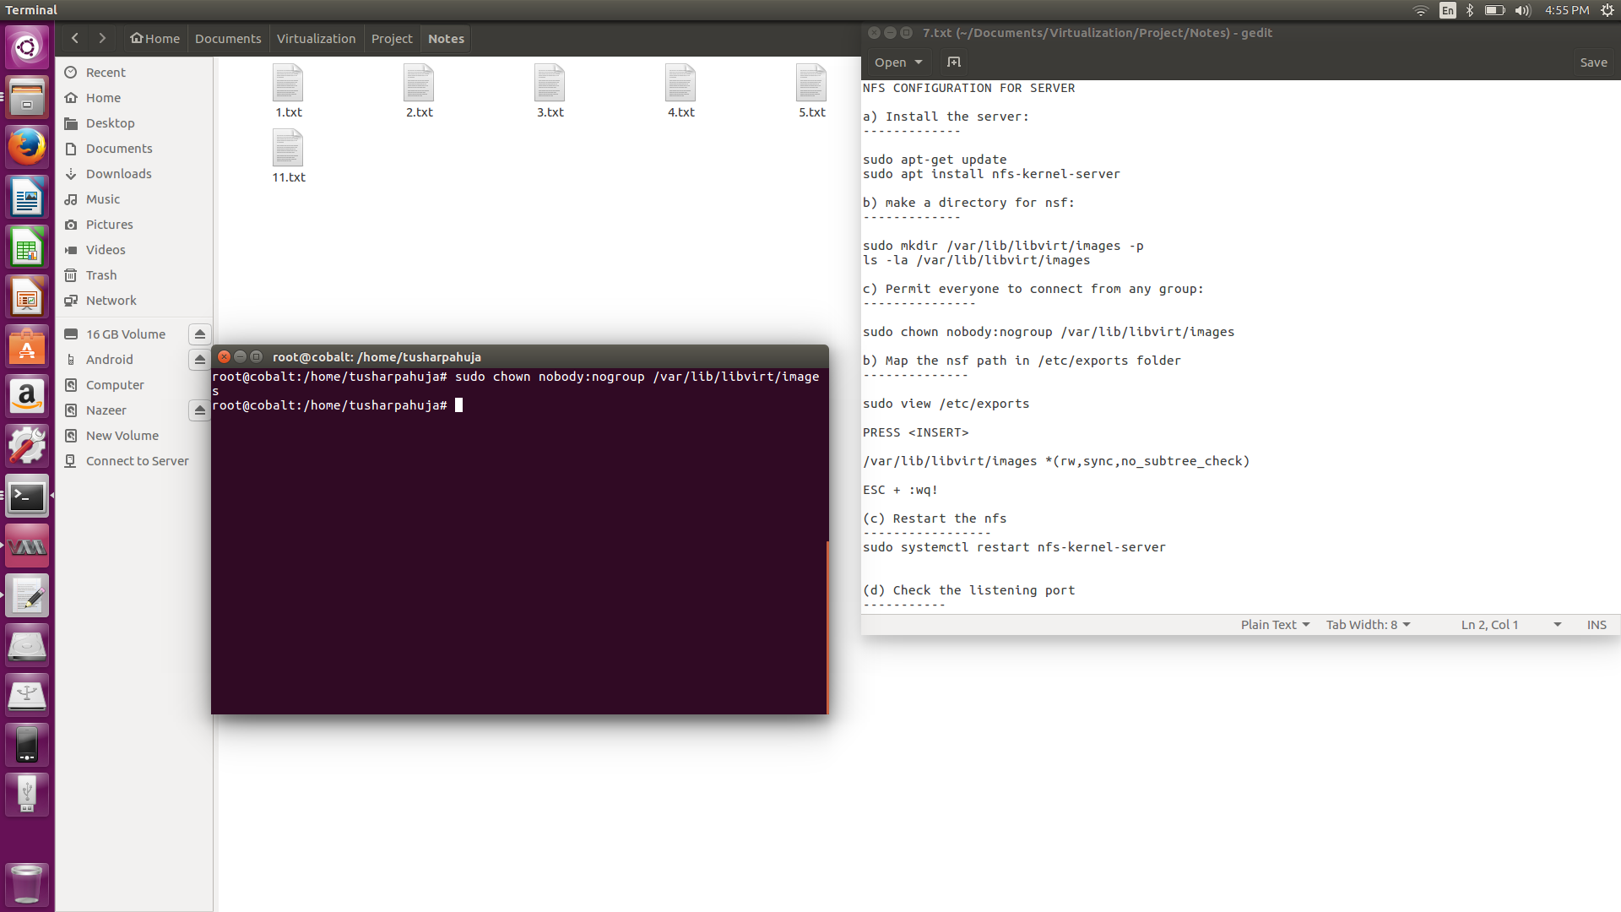

1. Map the NSF path in /etc/export folder:

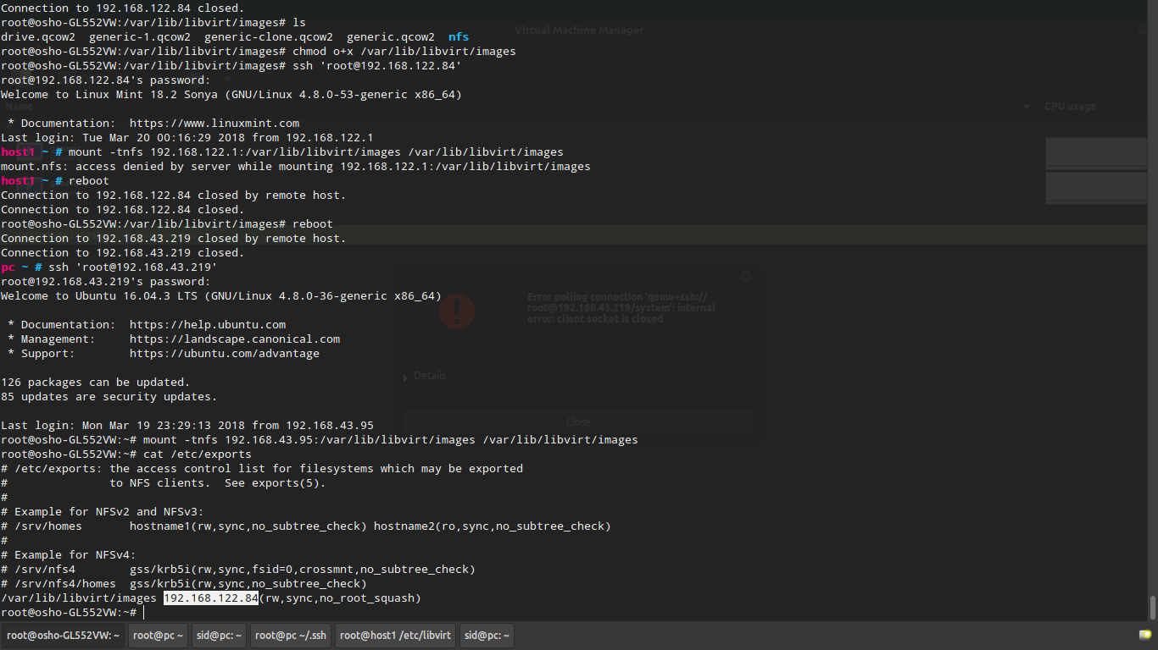

1. Restart the nfs-kernel-server

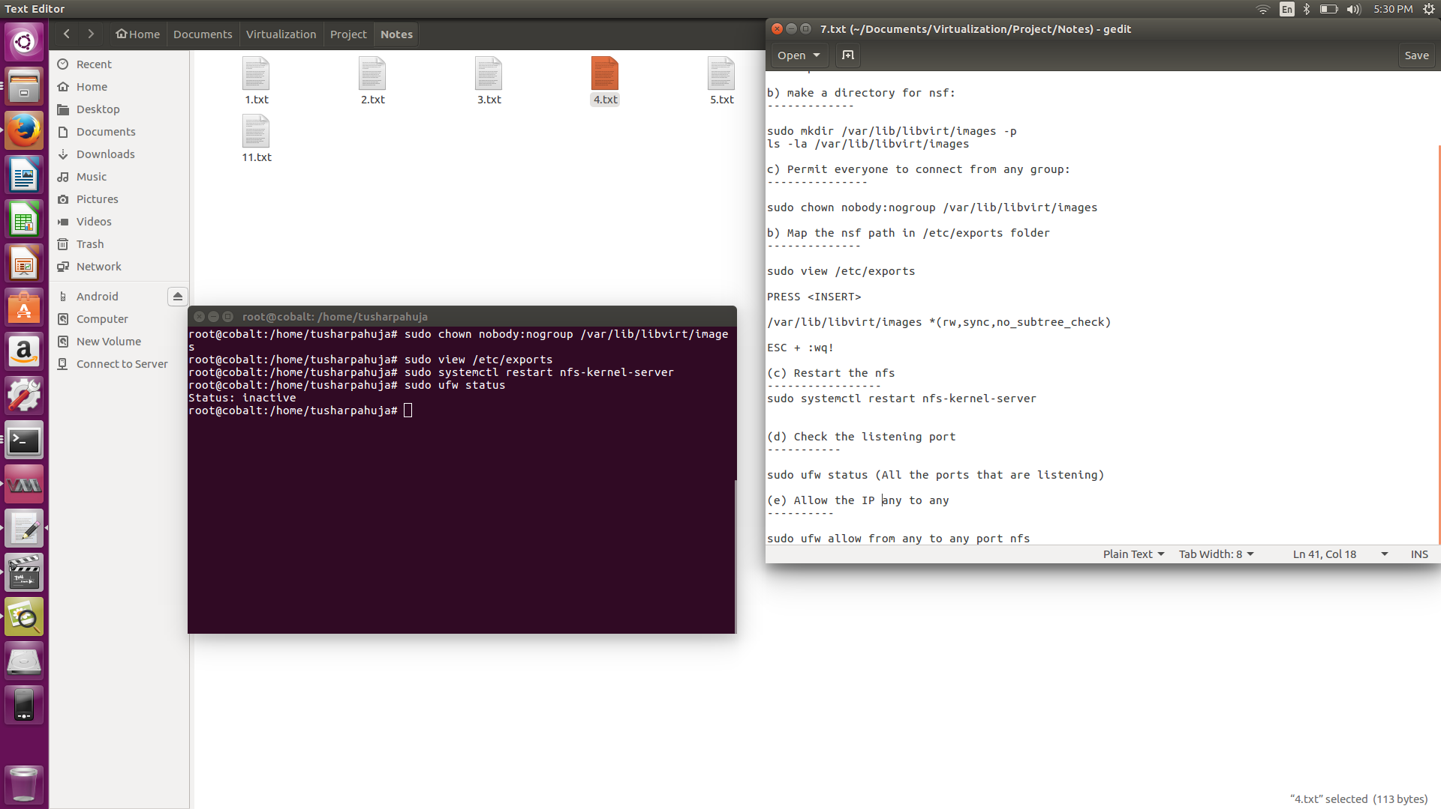

1. Check listening port after allowing from any to any port NFS

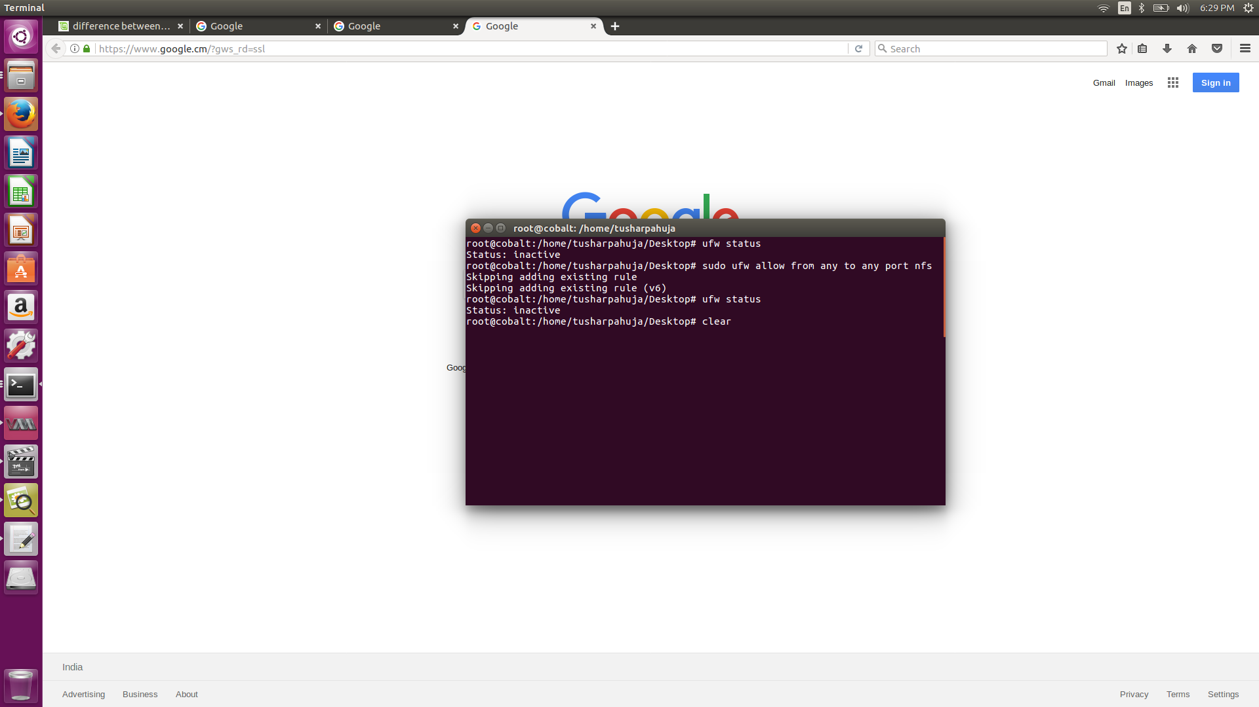

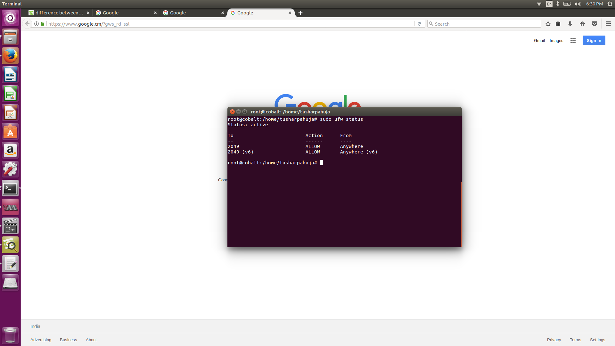

1. Mount the 2nd host in the directory of 1st host.

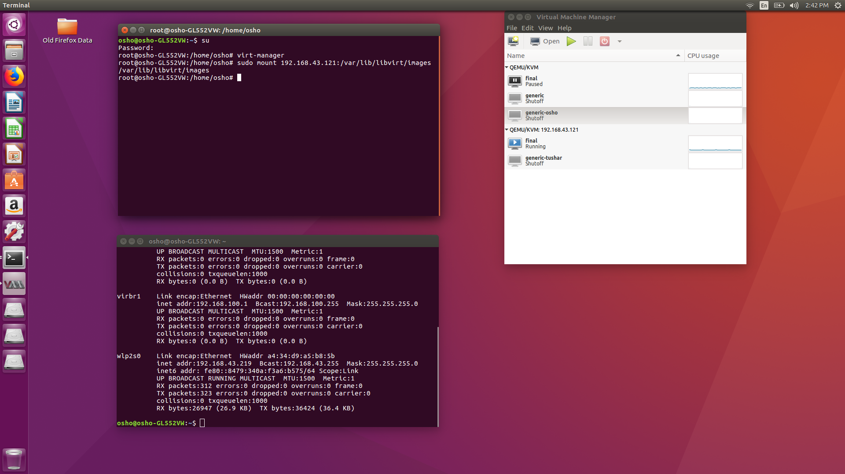

1. Verification of step 11

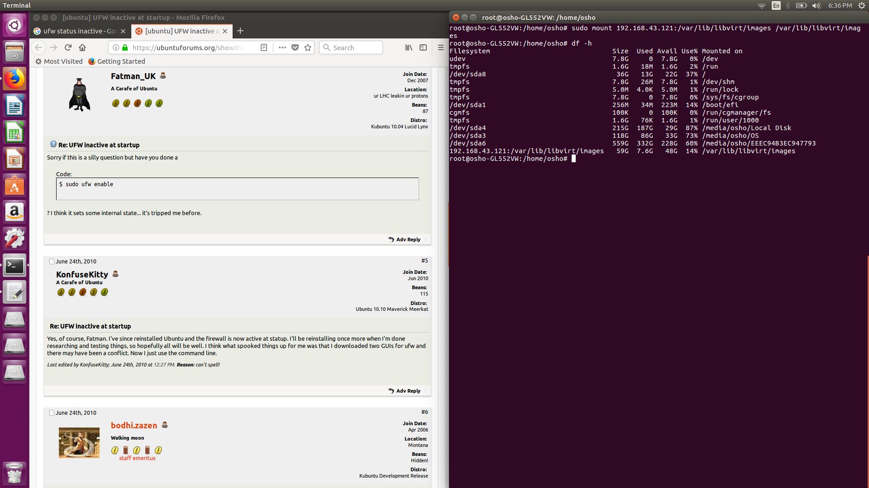

1. Checking daemon activity of libvirtd

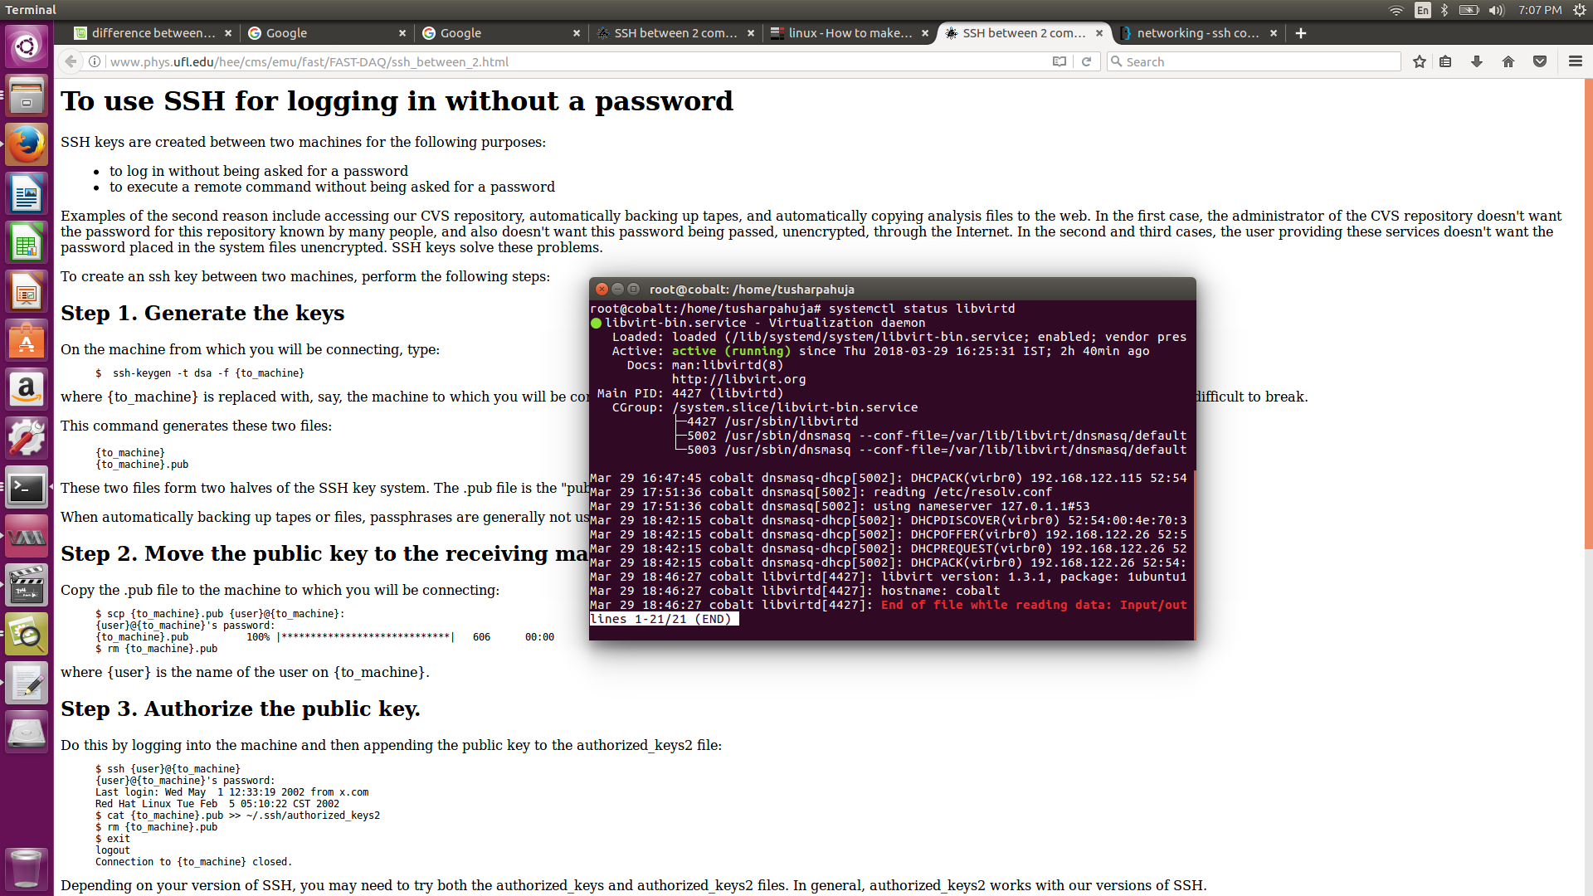

1. 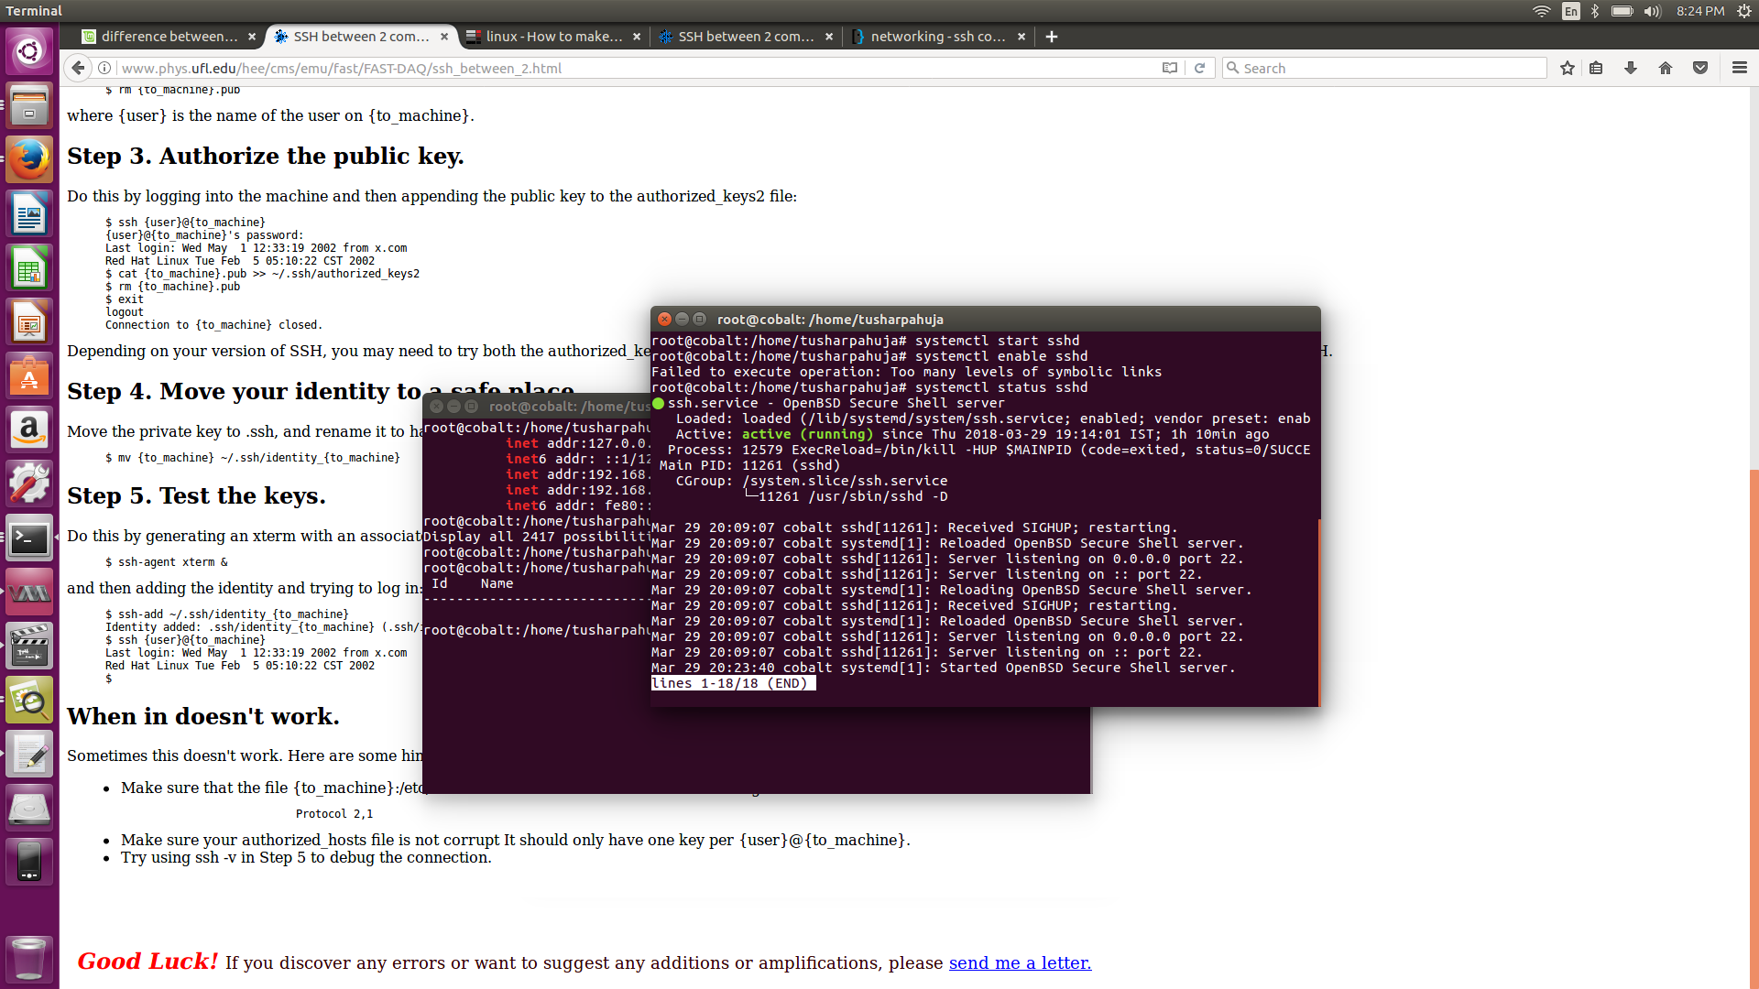Checking daemon activity of ssh server & completion of ssh:

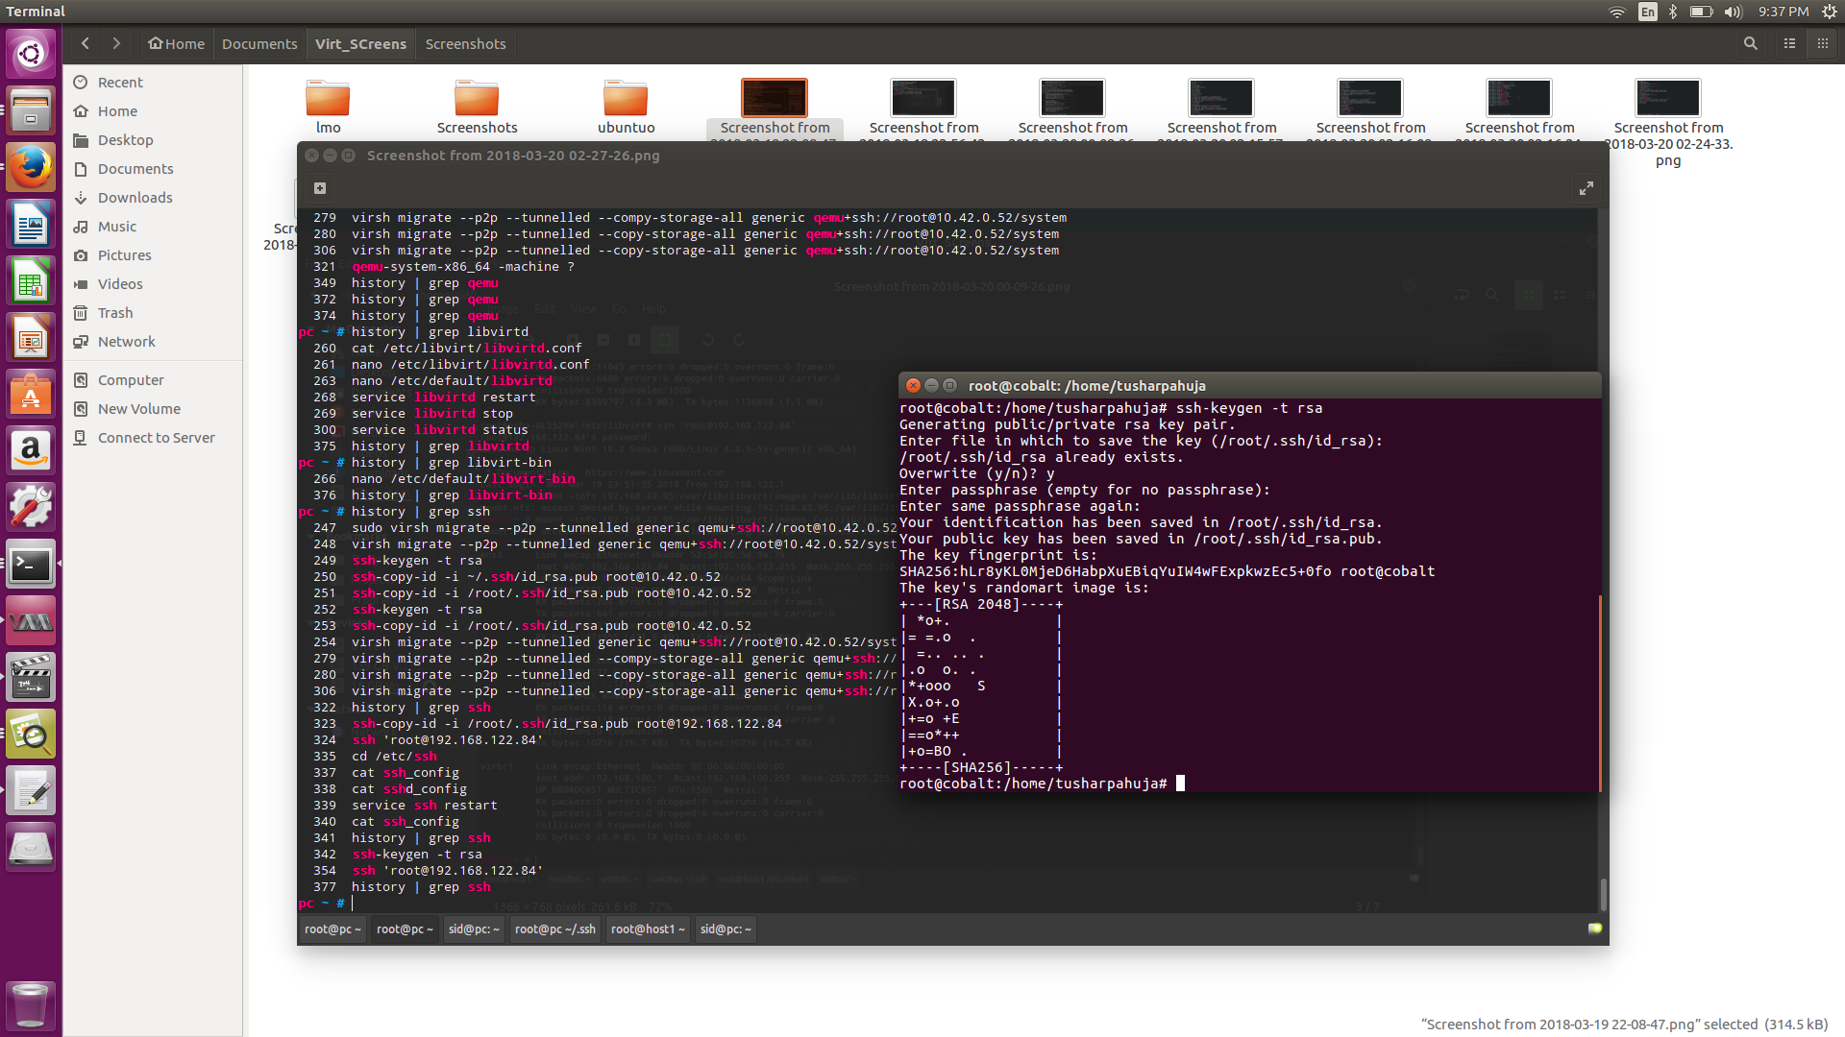

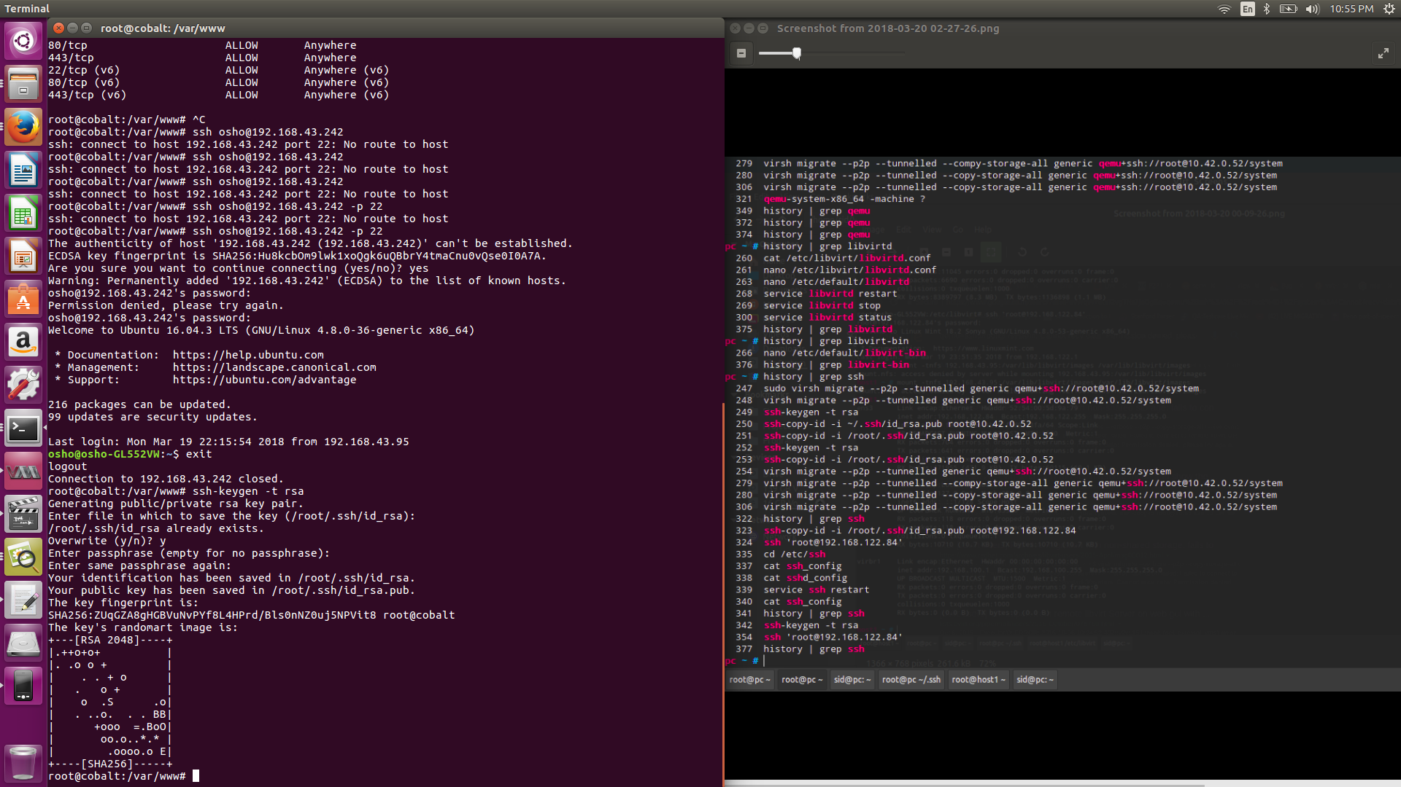

### EXPERIMENTATION RESULTS

The Live migration was carried out of the VM named “final” from 192.168.43.121 to 192.168.43.219 and vice versa after establishing connection:

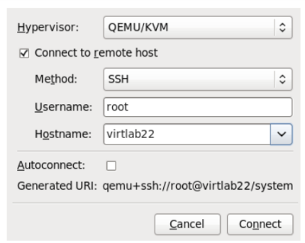

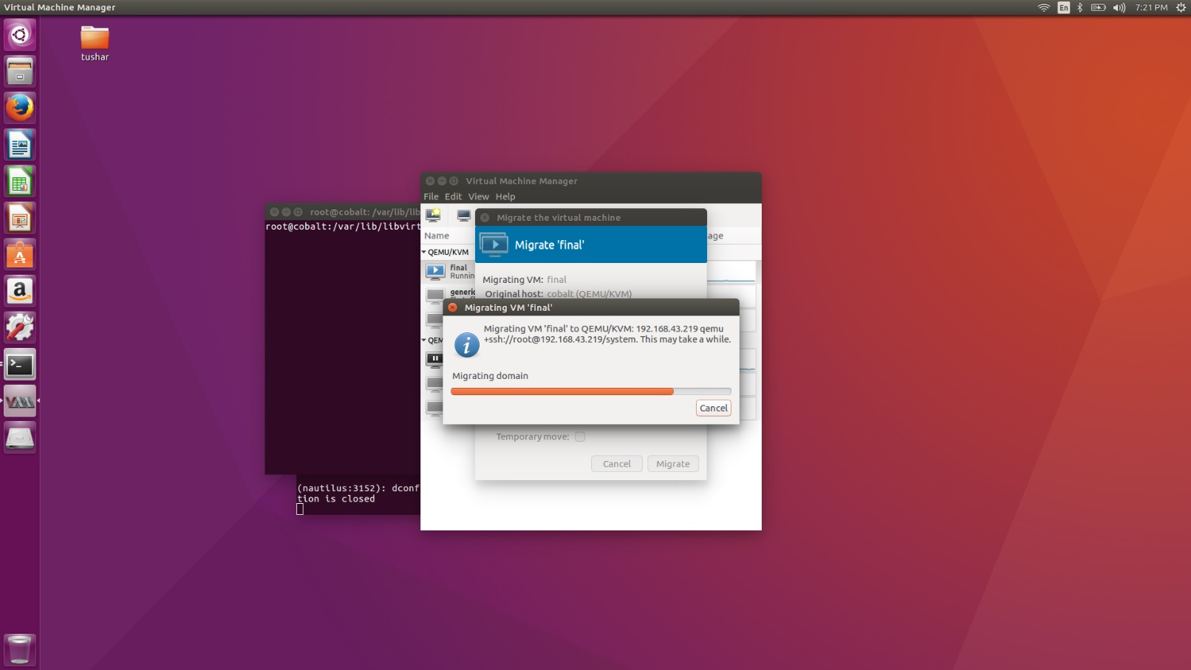

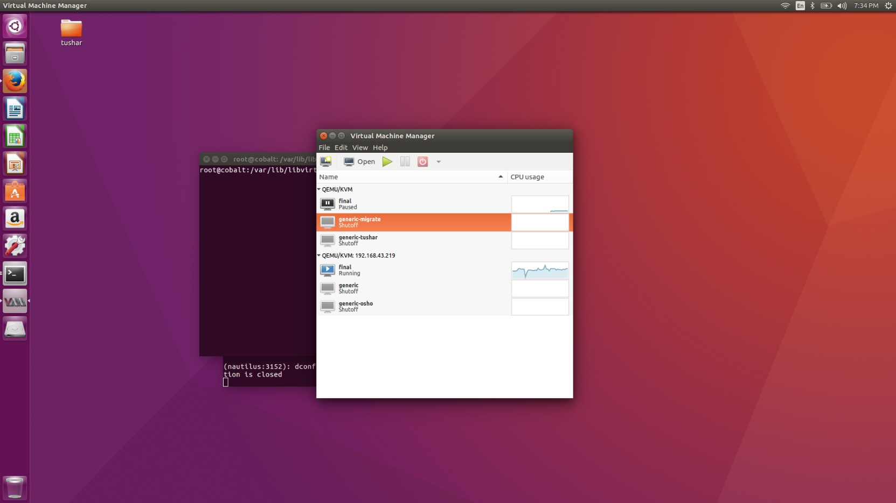

From 192.168.43.219 to 192.168.43.121 ----------

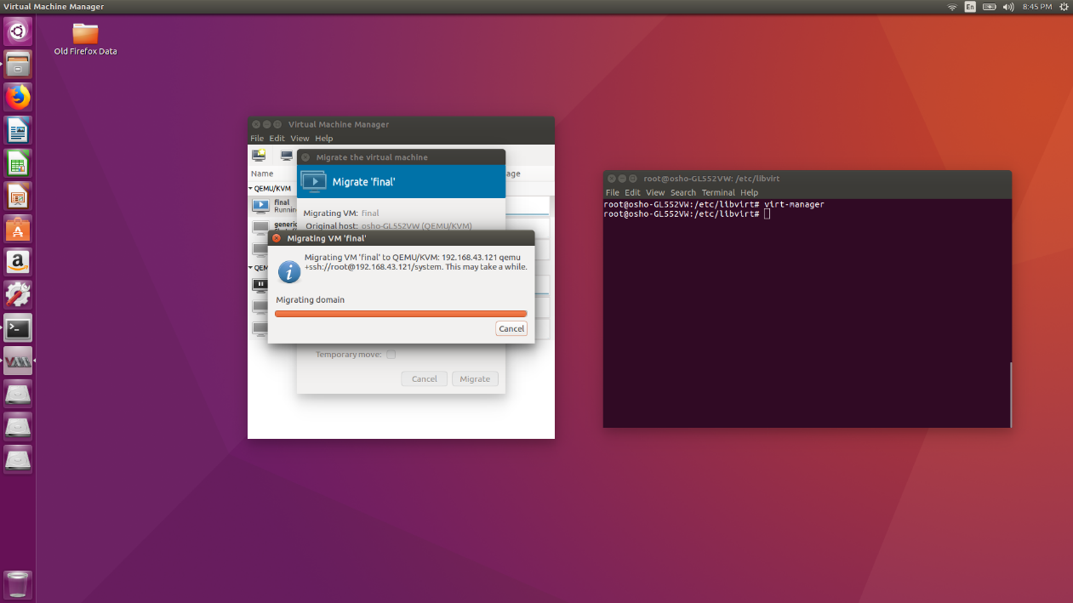

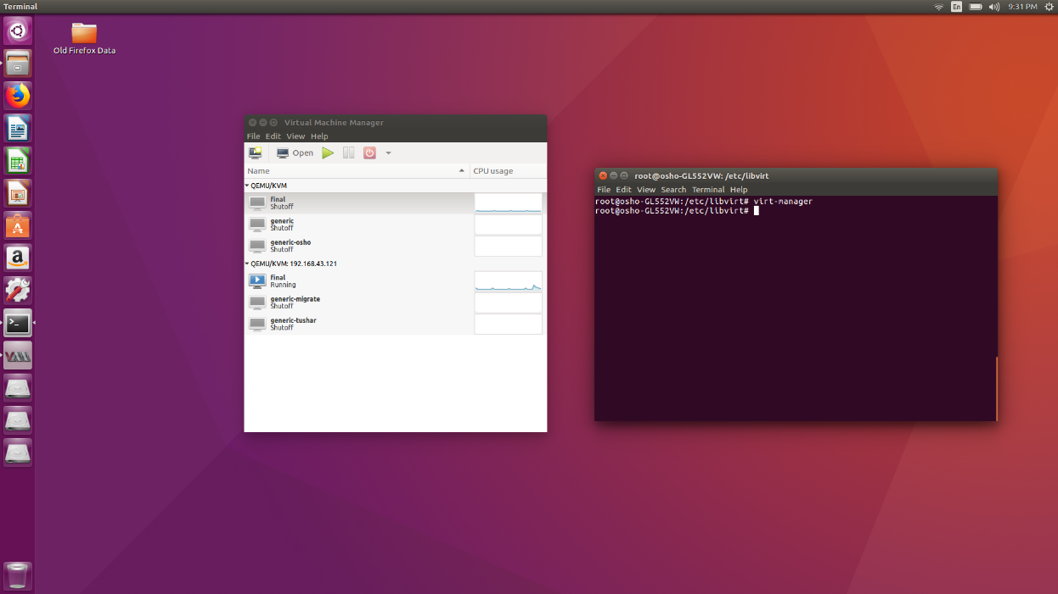

CONCLUSION

It was observed that in order to make the live migration work perfectly, certain daemons like libvirtd, apparmor, openssh need to be properly configured. These are implicit barriers which need to be resolved. The status of these daemons is to be checked using systemctl command as they need to be started, exited and again restarted.

This was a quick overview of the way live migration works for QEMU-KVM virtual machines.  There are several details available in the archives on the QEMU list.

Following references were used:

<https://developers.redhat.com/blog/2015/03/24/live-migrating-qemu-kvm-virtual-machines/>

<http://www.admin-magazine.com/Archive/2016/33/Live-migration-of-virtual-machines-with-KVM>

<https://fedoraproject.org/wiki/QA:Testcase_Live_Migration_using_libvirt/virsh>

<https://access.redhat.com/documentation/en-us/red_hat_enterprise_linux/6/html/virtualization_administration_guide/sect-virtualization-kvm_live_migration-migrating_with_virt_manager>

APPENDIX-COMMAND HISTORY

